

**Name**: Mirza Hammad Tariq

**Class**: BS-IT 6th (Morning)

**Roll** **No**: ITS-11065

**Subject**: Web Technologies

**Instructor**: Mr. Ahsan Arif

**Date**: Sep 27th, 2024

**Lab No**: 3

**Lab Task 1**

Using table tag, Create a web page CV with your skills. Give it a name Aboutme.html

**Activity**

Task 1 .html

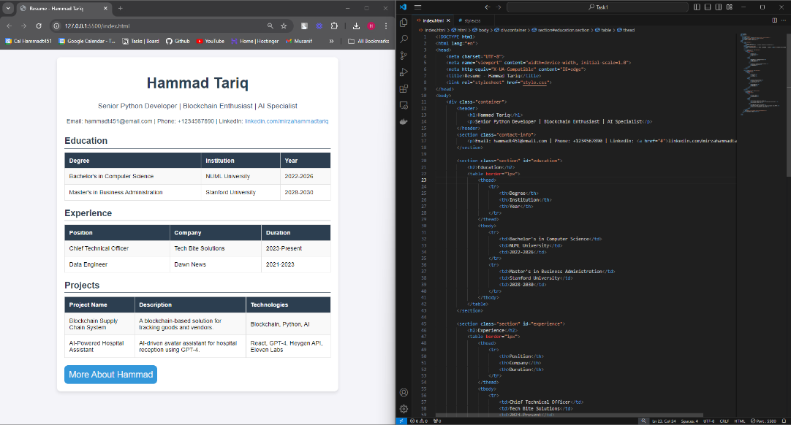

Figure 1

Task 1 .css

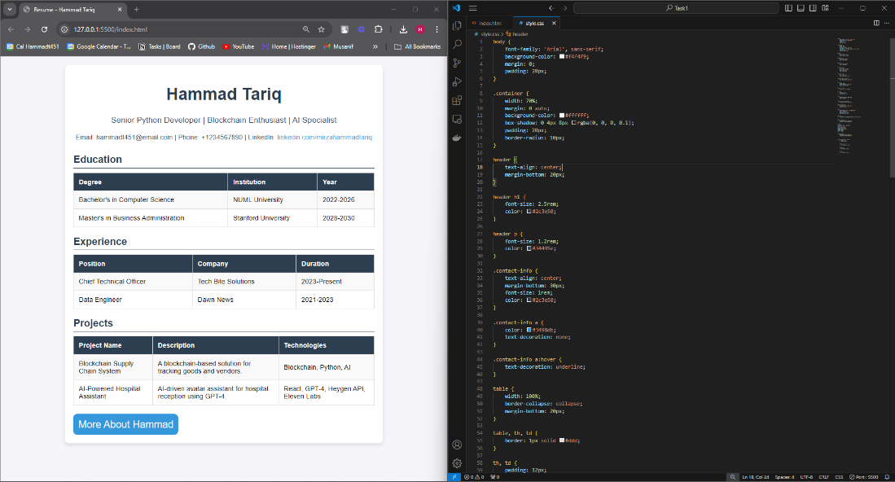

Figure 2

**Lab Task 2**

Create a web page containing description list , table styling, rowspan ,column span and column group

**Activity**

Task 2 .html

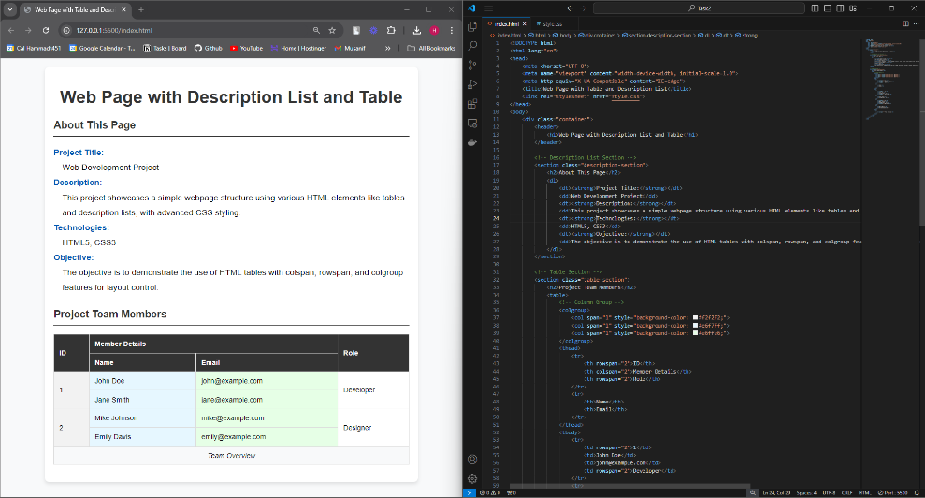

Figure 3

Task 2 .css

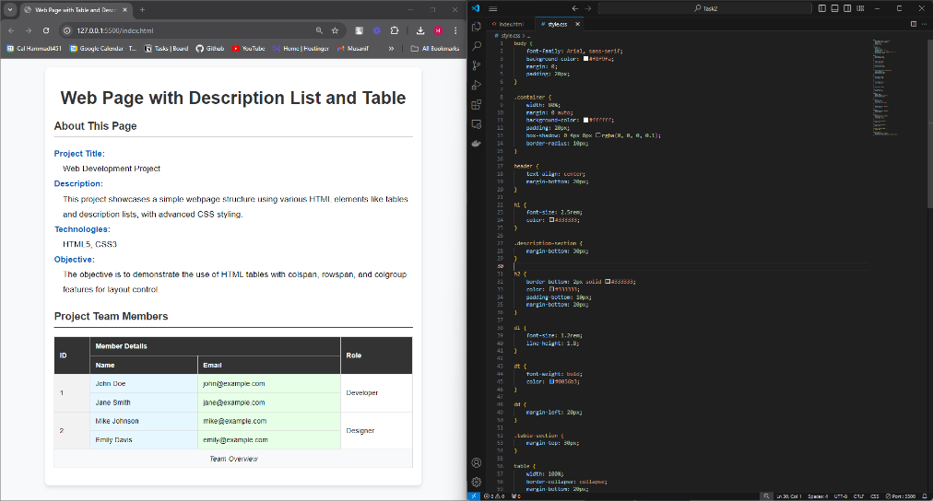

Figure 4